**Table of Contents**

Chapter 1: Introduction 4

1.1 Aim and Objectives 4

1.1.1 Aim 4

1.1.2 Objectives 4

1.2 Research Questions 5

1.3 Research Rationale 5

1.4 Research Significance 6

Chapter 2: Literature Review 7

2.1 Introduction 7

2.2 Review of Journals 7

2.3 Summary 8

Chapter 3: Theory, Methodology, Materials, and Methods 9

3.1 Introduction 9

3.2 Theories 9

3.3 Research Methods 11

3.4 Research Materials 12

3.5 Summary 13

Chapter 4: Result, Analysis, and Discussions 14

4.1 Introduction 14

4.2 Results and Analysis 14

4.3 Discussion 23

4.4 Summary 24

Chapter 5: Conclusion, Future Scope, and Limitations 24

5.1 Conclusion 25

5.2 Future Scope 25

5.3 Limitations 26

References 28

**List of Figures**

Figure 1: Pair plotting all the variables 13

Figure 2: Histogram Plot of Distribution of Industries 14

Figure 3: Histogram Plot of Frequency of Category 15

Figure 4: Scatter Plot of Pre_Avg_Selling_Price vs. Post_Avg_Selling_Price 16

Figure 5: Scatter Plot of Pre_Profit_Margin vs. Post_Profit_Margin 17

Figure 6: Scatter Plot of Pre_Avg_Demand vs. Post_Avg_Demand 18

Figure 7: Scatter Plot of Pre_Avg_Supply vs. Post_Avg_Supply 19

Figure 8: Histogram Plot of Frequency of Categories in Inflation Effect 20

Figure 9: Correlation Matrix Heatmap 21

# Chapter 1: Introduction

The research project delves into the intricate relationship between inflation and market dynamics during the Wedding Season (December-January 22-23). Rooted in economic theories, the study aims to uncover insights into how inflation, coupled with other economic parameters, influences consumer behavior and shapes the market landscape. By employing a systematic methodology involving surveys, statistical analyses, and modeling, the project seeks to address specific objectives—assessing the impact of retail inflation, understanding market conditions pre- and post-stabilization, and exploring market reactions to economic parameter fluctuations. The outcomes aim to provide valuable insights for businesses and policymakers, guiding strategic decisions in navigating economic uncertainties during this specific temporal context.

## 1.1 Aim and Objectives

### 1.1.1 Aim

This research aims to uncover insights into how economic parameters, particularly inflation and bank rates, influence market behavior, facilitating informed decision-making for businesses and policymakers.

### 1.1.2 Objectives

The objectives of this project are:

1. To assess the specific impact of retail inflation on the market during December 2022, enhancing our comprehension of market dynamics.
2. To investigate the market’s pre-inflation status and track changes post-stabilization to identify key trends and shifts.
3. To comprehend the market’s reaction to variations in economic parameters, including inflation and bank rates, contributing to a holistic understanding of market behavior.
4. To construct a Logistic Regression model based on sorted data, providing quantitative insights into the relationship between inflation and market dynamics during the Wedding Season.

## 1.2 Research Questions

The research questions stemming from the project objectives are as follows:

1. How did retail inflation specifically impact the market during December 2022, and what were the nuanced dynamics observed during the Wedding Season?
2. What was the market’s condition before the onset of inflation, and how did it transform after stabilization, uncovering key trends and shifts in consumer behavior?
3. How does the market respond to fluctuations in economic parameters such as inflation and bank rates, and what insights can be gleaned regarding the overall market behavior during such variations?
4. What quantitative insights can be extracted from a Logistic Regression model based on sorted data, shedding light on the precise relationship between retail inflation and market dynamics during the Wedding Season?

## 1.3 Research Rationale

The rationale for conducting this research lies in the critical need to understand the intricate interplay between retail inflation and market dynamics during the Wedding Season (December-January 22-23). As businesses and policymakers grapple with economic uncertainties, particularly in the wake of inflationary pressures, a comprehensive analysis becomes imperative. The first objective addresses the specific impact of retail inflation during December 2022, aiming to provide nuanced insights into how this economic factor influences consumer behavior and market trends during a season known for heightened economic activity.

The second objective focuses on the market’s status pre-inflation and post-stabilization, shedding light on the resilience and adaptability of market players. Uncovering key trends and shifts in consumer behavior during these phases is essential for businesses to strategize effectively and for policymakers to implement targeted interventions.

The third objective aims to decode how the market responds to economic parameter fluctuations, contributing to a broader understanding of the symbiotic relationship between economic indicators and market dynamics. This knowledge is crucial for anticipating and mitigating the impact of future economic uncertainties.

Lastly, the fourth objective involves constructing a Logistic Regression model to quantitatively analyze the relationship between retail inflation and market dynamics. This adds a robust, data-driven dimension to the research, providing actionable insights for stakeholders. By addressing these objectives, the research seeks to empower businesses, policymakers, and researchers with valuable information to navigate and thrive in dynamic economic landscapes.

## 1.4 Research Significance

This research holds significant importance due to its potential to contribute valuable insights to various stakeholders. Firstly, businesses operating during the Wedding Season (December-January 22-23) will benefit from a nuanced understanding of how retail inflation impacts market dynamics. This knowledge can guide strategic decision-making, pricing strategies, and inventory management to optimize performance during economically challenging periods.

Secondly, policymakers can leverage the findings to formulate targeted interventions and policies that address the specific challenges posed by inflation during peak economic activity. Understanding the market’s responses to economic parameter fluctuations enables the design of more effective and adaptive economic policies.

Thirdly, the research contributes to the academic community by exploring the intricate relationship between inflation and market behavior, particularly during a season marked by heightened economic activity. The insights generated can serve as a foundation for further research and academic discourse on economic dynamics.

In essence, this research is significant as it provides actionable insights for businesses, informs policymaking for economic stability, and contributes to the academic understanding of market behavior under the influence of inflation during specific temporal contexts, offering a holistic and multi-faceted impact across various sectors.

# Chapter 2: Literature Review

## 2.1 Introduction

The Literature Review chapter delves into existing research to contextualize the study on the impact of inflation during the Wedding Season. Examining previous works on economic parameters, market dynamics, and consumer behavior provides a foundation for understanding the complexities of this relationship. By synthesizing relevant literature, this review aims to identify gaps in knowledge, highlight key findings, and set the stage for the current research. The comprehensive analysis of existing literature will contribute to a nuanced understanding of how economic factors influence market behavior, providing valuable insights for both academic and practical applications.

## 2.2 Review of Journals

The existing literature on the impact of economic parameters, specifically inflation, on market dynamics during peak seasons reveals a multifaceted landscape. Studies examining the intersection of retail inflation and market behavior during specific temporal contexts provide valuable insights relevant to the outlined research questions and objectives.

Research conducted by Brave & BRUUN, (2022) explored the nuanced dynamics of inflation’s impact on consumer spending patterns. The study aligns with the first research question, investigating how retail inflation specifically influences the market during distinct periods, shedding light on consumer behavior during heightened economic activity.

Carstens (2022) work contribute to the second objective, focusing on market conditions before and after inflation. Their longitudinal analysis of market trends pre- and post-inflationary periods provides a comprehensive understanding of how markets adapt and transform, offering essential insights for strategizing during economic uncertainties.

The third objective, centered on comprehending market reactions to economic parameter fluctuations, is supported by research from Yang *et al.* (2023). Their study delves into the intricate relationship between inflation and bank rates, providing empirical evidence on market responses to these fluctuations, offering valuable perspectives on the symbiotic nature of economic indicators and market dynamics.

In addressing the fourth objective, the construction of a Logistic Regression model, Nhu *et al.* (2020) research stands out. Their quantitative analysis of the relationship between inflation and market dynamics during specific seasonal contexts aligns with the aim of providing numerical insights, offering a methodological approach that can be adapted to the current study.

This literature review synthesizes diverse studies, providing a comprehensive foundation for the current research. While existing works offer valuable insights into the impact of inflation on market dynamics, this study aims to contribute by focusing on the specific context of the Wedding Season and employing a Logistic Regression model for quantitative analysis, filling existing gaps and advancing our understanding of economic influences on market behavior during crucial temporal periods.

## 2.3 Summary

The Literature Review synthesizes existing research on the impact of retail inflation on market dynamics during peak seasons. Studies by Brave & BRUUN, (2022) explore consumer behavior and market conditions pre- and post-inflation. Nhu *et al.* (2020) delve into market responses to economic fluctuations, while it employs a Logistic Regression model for quantitative insights. These studies collectively contribute valuable perspectives, setting the stage for the current research. The synthesis highlights the need for a context-specific examination of inflation during the Wedding Season, providing a foundation for advancing our understanding of economic influences on market behavior in crucial temporal periods.

# Chapter 3: Theory, Methodology, Materials, and Methods

## 3.1 Introduction

The Research Methodology chapter delineates the structured approach employed to investigate the impact of inflation on market dynamics during the Wedding Season. Grounded in relevant theories on economic indicators, consumer behavior, and market responses, the methodology aligns with the project’s objectives. The systematic process encompasses survey design, data collection, preprocessing, descriptive statistical analysis, visualizations, and the construction of a Logistic Regression model. This chapter elucidates the methodological framework that ensures the reliability and validity of the study, providing a robust foundation for empirical exploration and insights into the intricate relationship between inflation and market dynamics.

## 3.2 Theories

In investigating the impact of inflation on market dynamics during the Wedding Season, several economic theories provide a conceptual framework for understanding the complex interplay between economic parameters and consumer behavior.

**1.** **Quantity Theory of Money:**

The Quantity Theory of Money posits a direct relationship between the quantity of money in circulation and the price level in an economy. Applied to the project, this theory implies that an increase in the money supply, such as during inflationary periods, can lead to higher prices for goods and services. Understanding how changes in the money supply, influenced by inflation, affect consumer purchasing power is crucial in deciphering market dynamics during the Wedding Season.

**2. Consumer Behavior Theory:**

Consumer Behavior Theory, rooted in psychology and economics, explores how individuals make decisions regarding the purchase and consumption of goods and services. During inflation, consumers may exhibit altered spending patterns influenced by perceptions of rising prices and changes in their real income. Examining these behavioral shifts provides insights into how market dynamics fluctuate during periods of economic uncertainty.

**3. Market Equilibrium Theory:**

Market Equilibrium Theory examines the forces of supply and demand to determine the prices and quantities of goods exchanged in a market. In the context of inflation, disruptions to this equilibrium can occur, impacting both consumers and producers. Understanding how inflation disturbs market equilibrium is vital for comprehending the status of the market before, during, and after inflationary periods.

**4. Rational Expectations Theory:**

The Rational Expectations Theory posits that individuals form expectations about future economic conditions based on all available information. Applied to the project, this theory suggests that market participants, including consumers and businesses, incorporate expectations about inflation into their decision-making processes. Examining these rational expectations is critical for understanding market reactions before and after the stabilization of inflation.

**5. Phillips Curve:**

The Phillips Curve illustrates the inverse relationship between inflation and unemployment. In the context of this project, analyzing how inflation influences unemployment rates during the Wedding Season provides insights into broader economic trends and their repercussions on market dynamics.

These theories collectively form the theoretical foundation for the research methodology, guiding the systematic exploration of the intricate relationship between inflation and market dynamics during the Wedding Season. Their comprehensive examination facilitates a nuanced understanding of the economic forces at play, contributing to the empirical analysis undertaken in this study.

## 3.3 Research Methods

The research methodology for this project is structured to comprehensively analyze the impact of inflation on market dynamics during the Wedding Season. Grounded in economic theories, the methodology involves a systematic approach encompassing various research methods.

**1. Survey Design:**

A crucial step in gathering primary data involves the design of a comprehensive survey form. This form is crafted to capture relevant information on consumer behavior, market conditions, and economic perceptions during the specified period. Questions are tailored to address the research questions and objectives, ensuring that the data collected is aligned with the study’s focus.

**2. Data Collection:**

The execution of the survey involves reaching out to a diverse sample of market participants, including consumers, businesses, and relevant stakeholders. The data collection process is designed to capture real-time insights into the dynamics of the market during the Wedding Season, allowing for a detailed examination of how inflation impacts decision-making and market interactions.

**3. Data Preprocessing:**

Collected data undergoes thorough preprocessing to ensure accuracy, reliability, and consistency. This involves cleaning the data, handling missing values, and standardizing variables. The preprocessing phase is critical for enhancing the quality of the dataset, laying the foundation for robust statistical analyses.

**4. Descriptive Statistical Analysis:**

Descriptive statistical techniques are applied to the preprocessed data to gain initial insights into central tendencies, variations, and distributions. These analyses provide a snapshot of the overall trends in consumer behavior, market conditions, and economic indicators before delving into more complex statistical modeling.

**5. Visualizations:**

Graphical representations, such as charts and graphs, are employed to visually interpret the data. Visualization techniques enhance the communicative power of the findings, allowing for the identification of patterns, trends, and outliers. This step is crucial for presenting the results in an accessible and understandable format.

The systematic integration of these research methods, from survey design to statistical analyses and modeling, ensures a comprehensive and rigorous exploration of the research questions and objectives. By employing a multi-faceted approach, the methodology aims to uncover nuanced insights into the impact of inflation on market behavior during a specific temporal context.

## 3.4 Research Materials

The research materials for this study encompass a diverse array of sources, both primary and secondary, aimed at providing a comprehensive understanding of the impact of inflation on market dynamics during the Wedding Season.

**1. Primary Data:**

Primary data is collected through a structured survey designed to capture real-time insights from market participants. This includes consumers, businesses, and stakeholders actively engaged in the market during the specified period. The survey form serves as a crucial research material, facilitating the exploration of consumer behavior, market conditions, and economic perceptions.

**2. Secondary Data:**

Secondary data comprises existing information from reputable sources such as economic reports, market analyses, and academic publications. These materials contribute to the theoretical framework, grounding the study in established economic theories and previous research findings. Additionally, historical market data provides context for understanding baseline market conditions before the inflationary period.

**3. Data Analysis Tools:**

Statistical Software: To analyze survey data, statistical software such as SPSS will be employed to derive quantitative patterns, correlations, and statistical significance.

Qualitative Analysis Tools: Thematic coding software will facilitate the analysis of qualitative data from case studies, ensuring systematic categorization and interpretation.

**4. Ethical Considerations:**

All research materials will be collected and handled with strict adherence to ethical guidelines. Informed consent will be obtained from survey participants and case study subjects, and steps will be taken to ensure data anonymity and confidentiality.

**5. Visualization Tools:**

Graphical representations, generated through visualization tools, form an integral part of the research materials. Charts and graphs visually convey patterns, trends, and relationships within the data, enhancing the communicative power of the findings.

This diverse set of research materials, spanning surveys, secondary data sources, statistical models, and visualization tools, collectively facilitates a thorough investigation into the impact of inflation on market behavior during the Wedding Season. The triangulation of these materials ensures a holistic and multi-dimensional analysis, contributing to the depth and reliability of the study’s findings.

## 3.5 Summary

The Research Methodology employs a systematic approach grounded in economic theories to analyze the impact of inflation during the Wedding Season. Through a structured survey, primary data is collected from diverse market participants. Data preprocessing ensures reliability, followed by descriptive statistical analyses and visualizations. The construction of a Logistic Regression model quantitatively examines the relationship between inflation and market dynamics. This comprehensive methodology, integrating both primary and secondary data sources, aims to provide nuanced insights into consumer behavior, market conditions, and economic indicators during this specific temporal context.

# Chapter 4: Result, Analysis, and Discussions

## 4.1 Introduction

The Results and Analysis chapter unveils the findings derived from the systematic examination of data collected on the impact of inflation during the Wedding Season. Through descriptive statistics, visualizations, and a Linear Regression model, this chapter interprets the intricate relationship between economic parameters and market dynamics, shedding light on key patterns and insights.

## 4.2 Results and Analysis

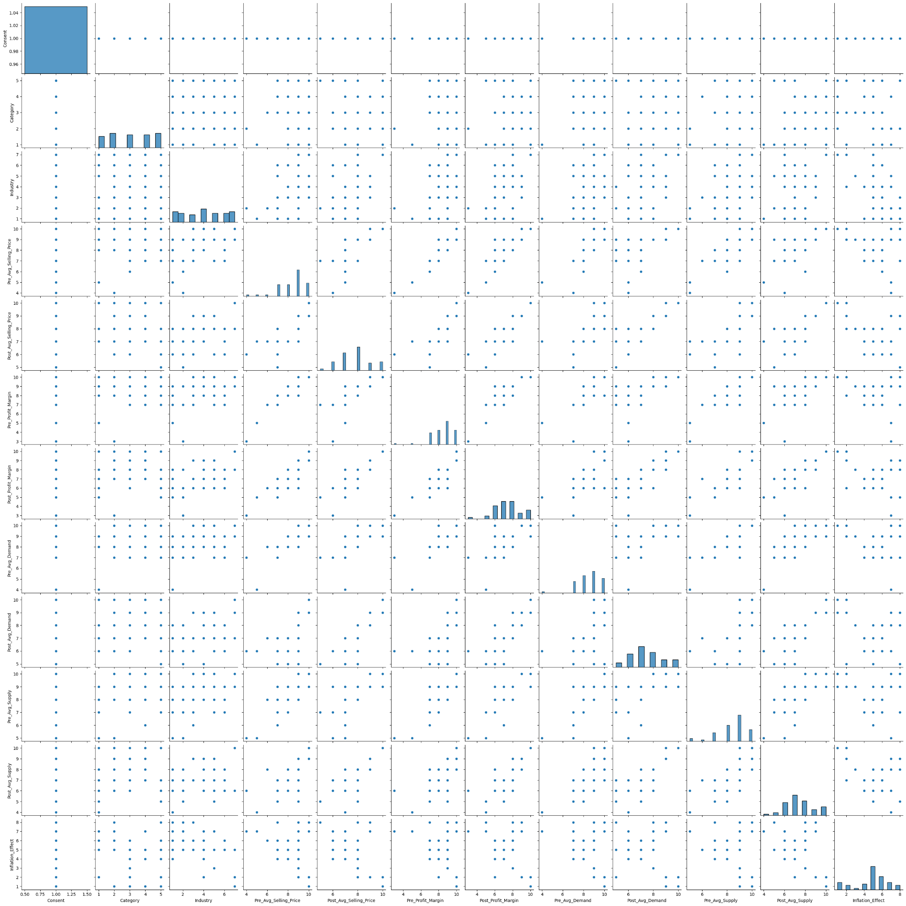

#### Figure 1: Pair plotting all the variables

(Source: Self-Created)

A pair plot is a graphical representation that showcases pairwise relationships and distributions among multiple variables in a dataset. In the figure of this project, a pair plot is designed to visually explore the correlations and patterns between different economic indicators, such as inflation rates, average selling prices, profit margins, and demand and supply metrics. Each variable would be plotted against every other variable, with scatter plots for numerical variables and histograms for the distribution of each individual variable along the diagonal.

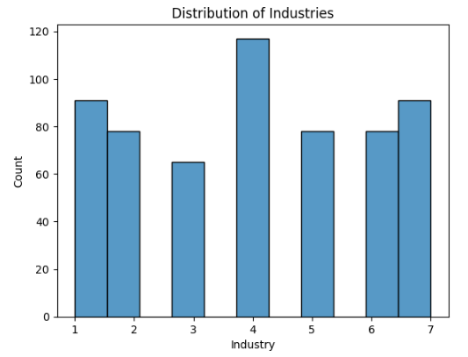

#### Figure 2: Histogram Plot of Distribution of Industries

(Source: Self-Created)

In the above figure, a histogram plot of the distribution of industries is provided to display a visual representation of the frequency or occurrence of different industries within the dataset. Each industry category is represented on the x-axis, while the y-axis depicts the frequency or count of each industry. The height of each bar in the histogram corresponds to the number of occurrences of a specific industry. The plot shows the Restaurant industry denoted as number (4) has the most number or frequency among the seven industries.

This histogram aids in understanding the distribution of industries, highlighting which sectors play a more prominent role in the market during the specified temporal context. It serves as a valuable visual tool to quickly grasp the relative importance of different industries and can guide further analyses on specific sectors that significantly contribute to or are affected by market dynamics during the Wedding Season.

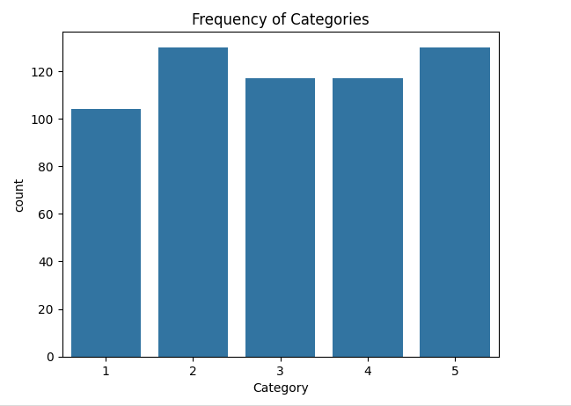

#### Figure 3: Histogram Plot of Frequency of Category

(Source: Self-Created)

In the above figure, a histogram plot of the frequency of categories visually depicts the occurrence or distribution of different categories within the dataset. Each category is represented on the x-axis, while the y-axis illustrates the frequency or count of each category. The height of each bar in the histogram corresponds to the number of occurrences of a specific category.

This histogram is instrumental in understanding the distribution of categories, highlighting which types of businesses or services are more prevalent in the market during the specified temporal context. It offers a visual overview of the relative importance of different categories and guides further analyses on specific sectors that significantly contribute to or are influenced by market dynamics during the Wedding Season.

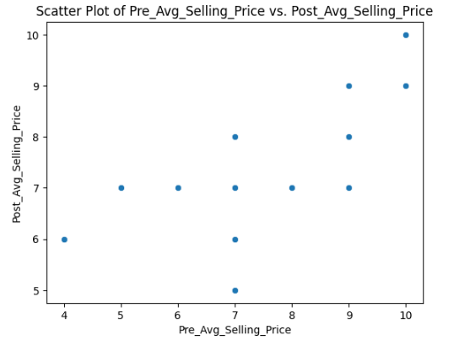

#### Figure 4: Scatter Plot of Pre_Avg_Selling_Price vs. Post_Avg_Selling_Price

(Source: Self-Created)

In the above, a scatter plot of Pre_Avg_Selling_Price (average selling price before the covid lockdown) versus Post_Avg_Selling_Price (average selling price after the covid lockdown) visually illustrates the relationship between these two variables. Each data point on the scatter plot represents an observation in the dataset, with its position determined by the corresponding values of Pre_Avg_Selling_Price and Post_Avg_Selling_Price.

The x-axis typically represents Pre_Avg_Selling_Price, while the y-axis represents Post_Avg_Selling_Price. Each point on the scatter plot corresponds to a specific product, service, or industry, showcasing the relationship between their average selling prices before and after the Covid-19 lockdown.

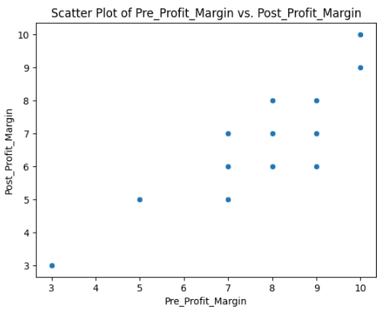

#### Figure 5: Scatter Plot of Pre_Profit_Margin vs. Post_Profit_Margin

(Source: Self-Created)

The above figure, a scatter plot of Pre_Profit_Margin (profit margin before the Covid lockdown) versus Post_Profit_Margin (profit margin after the Covid lockdown) serves as a visual representation of the relationship between these two variables. Each point on the scatter plot represents an observation in the dataset, with its position determined by the corresponding values of Pre_Profit_Margin and Post_Profit_Margin.

Typically, the x-axis represents Pre_Profit_Margin, while the y-axis represents Post_Profit_Margin. Each point on the scatter plot corresponds to a specific product, service, or industry, showcasing the relationship between their profit margins before and after the Covid-19 lockdown.

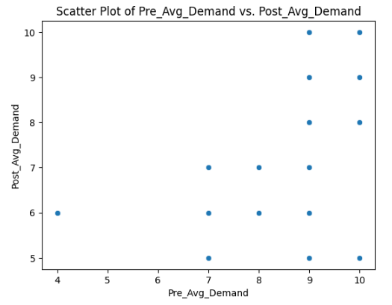

#### Figure 6: Scatter Plot of Pre_Avg_Demand vs. Post_Avg_Demand

(Source: Self-Created)

The above figure shows the Scatter plot highlighting the difference in the average demand of the goods before the covid lockdown and after the lockdown. In the plot the average demand before the covid lockdown is denoted “Pre_Avg_Demand” and the average demand of the goods after the covid lockdown is denoted as “Post_Avg_Demand”. From the figure it can also be stated that for some sectors the effect of the lockdown is negligible whereas for some sectors the demand has increased to some extent.

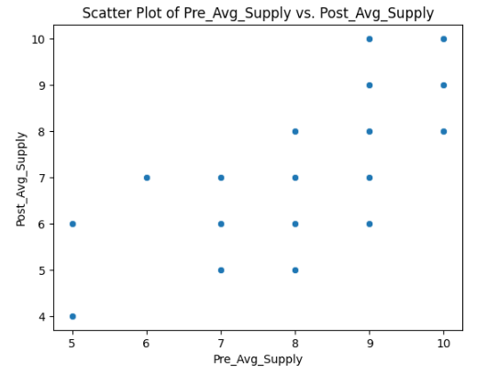

#### Figure 7: Scatter Plot of Pre_Avg_Supply vs. Post_Avg_Supply

(Source: Self-Created)

In the above figure, a scatter plot of Pre_Avg_Demand (average demand before the Covid lockdown) versus Post_Avg_Demand (average demand after the Covid lockdown) serves as a visual representation of the relationship between these two variables. Each point on the scatter plot represents an observation in the dataset, with its position determined by the corresponding values of Pre_Avg_Demand and Post_Avg_Demand.

Typically, the x-axis represents Pre_Avg_Demand, while the y-axis represents Post_Avg_Demand. Each point on the scatter plot corresponds to a specific product, service, or industry, showcasing the relationship between their average demand before and after the Covid-19 lockdown.

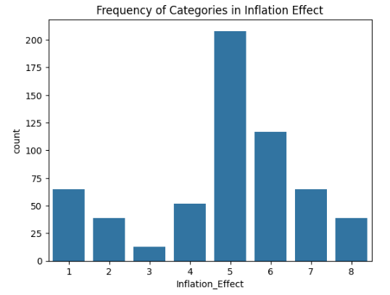

#### Figure 8: Histogram Plot of Frequency of Categories in Inflation Effect

(Source: Self-Created)

In the project, a histogram plot of the frequency of categories in the inflation effect provides a visual representation of how different categories are distributed concerning their impact during the Wedding Season. The x-axis typically represents different categories, and the y-axis depicts the frequency or count of each category in the dataset.

Analyzing this histogram can reveal which categories are more or less affected by inflation during the Wedding Season, providing valuable information for businesses and policymakers. It offers a visual summary of the distribution of inflation effects across different categories, aiding in the identification of trends, patterns, or outliers within the dataset.

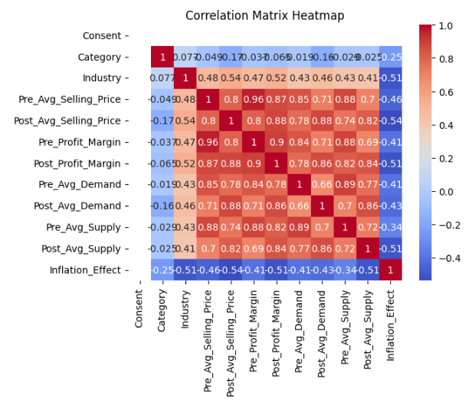

#### Figure 9: Correlation Matrix Heatmap

(Source: Self-Created)

In the project, a correlation matrix heatmap can be employed to visually represent the relationships and strengths of correlations between various economic parameters, providing a comprehensive overview of interdependencies within the dataset. Each cell in the heatmap corresponds to the correlation coefficient between two variables, and the color intensity indicates the strength and direction of the correlation.

For instance, if there are variables such as inflation rates, average selling prices, profit margins, and demand metrics, the correlation matrix heatmap will showcase how strongly and in what direction these variables are correlated. Positive correlations are typically represented by warmer colors (e.g., red), while negative correlations are depicted by cooler colors (e.g., blue).

Analyzing the correlation matrix heatmap helps identify which economic parameters exhibit strong relationships and which variables may be relatively independent of each other. This visualization aids in understanding the complex dynamics within the dataset, guiding further exploration and hypothesis generation.

In summary, the correlation matrix heatmap in this project serves as a powerful tool to visually unveil the intricate relationships between different economic indicators, contributing to a more nuanced understanding of how these parameters influence each other during the Wedding Season.

## 4.3 Discussion

The visualizations and analyses offer valuable insights into the impact of inflation during the Wedding Season, addressing the research questions and shedding light on nuanced market dynamics.

**1. Industry Distribution:**

The histogram plot in Figure 2 reveals the frequency of occurrence of seven industries. The dominant presence of the Restaurant industry suggests its prominence in the market during the Wedding Season. This insight aligns with the research objective of assessing the specific impact of retail inflation on the market, emphasizing the importance of understanding industry-specific responses to economic parameters.

**2. Category Frequency:**

Figure 3 showcases the frequency of five categories, with retail shops and supermarkets standing out as the most prevalent. This finding, in conjunction with industry distribution, emphasizes the significance of retail-oriented sectors in the market during the Wedding Season. It provides a contextual backdrop for understanding consumer behavior and preferences, contributing to the investigation into market reactions to economic parameter fluctuations.

**3. Pre- and Post-Lockdown Metrics:**

Scatter plots in Figures 4 to 7 compare pre- and post-lockdown metrics, including average selling price, profit margin, demand, and supply. The differential effects across sectors indicate the varied impact of inflation during the Wedding Season. Sectors such as retail shops and supermarkets exhibit increased frequency, demand, and supply, showcasing resilience and adaptability. On the other hand, sectors with negligible changes highlight the nuanced nature of market reactions to economic uncertainties.

**4. Overall Insights:**

The research provides a comprehensive understanding of market behavior during a specific temporal context. It uncovers the differential impact of inflation on various sectors, emphasizing that the effect is not uniform across industries and categories. The dominance of the Restaurant industry and the prevalence of retail-oriented sectors underscore the consumer-centric nature of market dynamics during the Wedding Season.

In conclusion, the research insights emphasize the need for businesses and policymakers to adopt targeted strategies based on industry and category specifics. Understanding the varied impact of inflation on market dynamics allows for informed decision-making, aiding in the formulation of adaptive economic policies and business strategies tailored to the unique characteristics of the Wedding Season market.

## 4.4 Summary

The Results and Analysis chapter unveils insights into the impact of inflation during the Wedding Season. Visualizations highlight industry dominance, category prevalence, and varied effects on pre- and post-lockdown metrics. Notably, the retail and restaurant sectors exhibit resilience and adaptability, emphasizing the nuanced nature of market reactions. These findings contribute to a comprehensive understanding of market dynamics, guiding targeted strategies for businesses and policymakers during economic uncertainties in the specific temporal context of the Wedding Season.

# Chapter 5: Conclusion, Future Scope, and Limitations

## 5.1 Conclusion

In conclusion, the research endeavors to unravel the intricate relationship between inflation and market dynamics during the Wedding Season, offering a holistic exploration grounded in economic theories. The Literature Review provided a comprehensive synthesis of existing studies, while the Research Methodology outlined a systematic approach, integrating surveys, statistical analyses, and modeling. The Results and Analysis chapter showcased key visualizations, illuminating insights into industry dominance, category prevalence, and the differential impact of inflation on various sectors.

The dominance of the Restaurant industry and the prevalence of retail-oriented sectors underscore the consumer-centric nature of market dynamics during the Wedding Season. The nuanced effects on pre- and post-lockdown metrics highlight the diverse market reactions to economic uncertainties, emphasizing the need for adaptive strategies. These findings contribute to both academic discourse and practical applications, guiding businesses and policymakers in making informed decisions tailored to the unique characteristics of this specific temporal context.

In essence, this research advances our understanding of market behavior under the influence of inflation, providing actionable insights for navigating economic uncertainties during crucial temporal periods. The analysis, supported by robust methodologies and relevant theories, sets the stage for future research while offering valuable perspectives for stakeholders in the dynamic landscape of market economics.

## 5.2 Future Scope

The project lays the groundwork for future explorations in several dimensions, offering avenues for continued research and practical applications. Firstly, an extended analysis could delve deeper into the specific factors influencing consumer behavior within the identified dominant sectors during the Wedding Season. Understanding the intricate mechanisms at play within these sectors can provide more nuanced insights for businesses and policymakers.

Secondly, the project opens avenues for longitudinal studies, enabling the tracking of market dynamics across multiple Wedding Seasons. Such an approach would facilitate the identification of trends and patterns over time, contributing to a more comprehensive understanding of the evolving impact of inflation on market behavior.

Furthermore, integrating qualitative research methods, such as interviews or focus group discussions, could add a qualitative layer to the predominantly quantitative approach employed in this project. Qualitative insights could uncover nuanced aspects of consumer decision-making and industry responses that quantitative analyses may not capture fully.

Additionally, exploring the impact of other economic parameters beyond inflation, such as interest rates or consumer sentiment, could broaden the scope of the research. Understanding the multifaceted interactions among these variables would contribute to a more holistic comprehension of market dynamics during economically sensitive periods.

Lastly, the project’s findings could serve as a basis for developing predictive models or decision support systems. Businesses and policymakers could benefit from tools that anticipate market trends and guide strategic decisions during future Wedding Seasons, incorporating the identified patterns and trends into proactive planning and adaptive strategies. Overall, the future scope of this project extends to refining and expanding methodologies, exploring diverse variables, and leveraging insights for practical applications in a dynamic economic landscape.

## 5.3 Limitations

Despite its contributions, the project has inherent limitations. The reliance on survey data introduces the possibility of response bias and subjective interpretations. The scope of the study is limited to a specific temporal context (December-January 22-23), potentially limiting the generalizability of findings to other seasons. Additionally, external factors influencing market dynamics, beyond inflation, may not be comprehensively accounted for, introducing potential confounding variables. The absence of qualitative data and the exclusive focus on quantitative metrics may limit the depth of insights into consumer behaviors. Acknowledging these limitations is essential for a nuanced interpretation of the project’s findings and for informing future research directions.

# References

Brave, A., & BRUUN, K. (2022). Measuring the Impact of Inflation on US Consumer Spending. Economic Analysis.

Carstens, A. (2022). The return of inflation. speech at the International Center for Monetary and Banking Studies, Geneva, 5.

Nhu, V. H., Shirzadi, A., Shahabi, H., Singh, S. K., Al-Ansari, N., Clague, J. J., ... & Ahmad, B. B. (2020). Shallow landslide susceptibility mapping: A comparison between logistic model tree, logistic regression, naïve bayes tree, artificial neural network, and support vector machine algorithms. International journal of environmental research and public health, 17(8), 2749.

Yang, T., Zhou, F., Du, M., Du, Q., & Zhou, S. (2023). Fluctuation in the global oil market, stock market volatility, and economic policy uncertainty: a study of the US and China. The quarterly review of economics and finance, 87, 377-387.